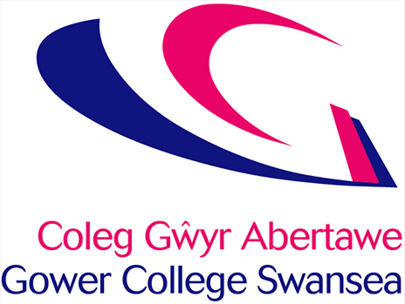

**Gower College Swansea**

**Strategic Equality Plan 2024-2028**

# **Principal Welcome**

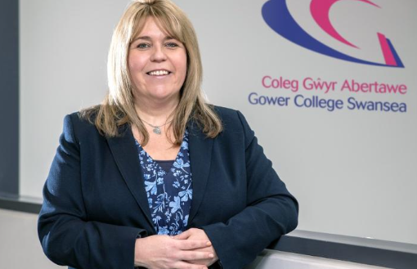

At Gower College Swansea we pride ourselves in being an inclusive institution that celebrates diversity across all areas of our College community.  As we continue to expand in terms of the range of provision we offer, and welcome learners from increasingly diverse backgrounds, we recognise that are journey towards true inclusivity is ongoing.

In acknowledging this, we also recognise the need for continued focused efforts as outlined in our Equality and Diversity Strategic Plan.  Our plan sets out key objectives and actions for achieving Equality, Diversity and Inclusion based around ongoing monitoring and evaluation. It is designed to help us identify areas for improvement within our College community and achieve real progress for both learners and staff.

Central to our mission is to continually increase our understanding of the challenges faced by our learners and staff, supporting them in their success and celebrating the diversity throughout our College community.

We aim that in the creation and development of these objectives we can overcome barriers and inequalities highlighted by our staff and learners and in doing so create a college community that is inclusive, compassionate and welcomes diversity. The college believes that in achieving these objectives both staff and learners will feel valued, supported, and empowered to achieve their full potential regardless of their background or any characteristics.

**Kelly Fountain**

**Principal**

# **PSED & Equality Act**

The Equality Act 2010 and the public sector duty that came shortly after, places an equality duty on public sector bodies such as Gower College Swansea. The duty states that as an educational establishment we must also have due regard in achieving the following:

* Eliminating discrimination, harassment, victimisation and any other conduct that is prohibited under the act.
* Advance equality of opportunity between persons who share a relevant protected characteristic and persons who do not share it
* Foster good relations between persons who share a relevant protected characteristic and persons who do not share it.

The Government and the Equality and Human Rights Commission (EHRC) have made it clear that public bodies, including colleges of further education, must mainstream equality in both their internal and externally facing functions, and the duty provides a mechanism for ensuring our policies, practices and procedures do not place anyone at a disadvantage.

Gower College Swansea is committed to these principles of mainstreaming equality. We understand that mainstreaming equality issues will ensure that we deliver our aims in a more meaningful way, which will reach all groups in our community more effectively. In April 2011 Welsh Government introduced regulations putting in place a series of specific duties to underpin the general duty. These are:

* To publish equality objectives which are to be reviewed every 4 years;
* To publish a statement setting out the steps that is has taken or intends to take in order to fulfil each objective and the timescale to achieve;
* To monitor the progress and effectiveness of the steps taken;
* To identify, seek out and where appropriate, publish information that can be used to gauge whether the general duty is being met
* To carry out and publish impact assessments showing how it’s current and proposed policies and practices affect the organisation’s ability to comply with the general duty
* On an annual basis, collect and publish certain employee data by reference to protected characteristics
* To promote employee’s understanding of the general and specific duties

The protected characteristics outlined in the Equality Act 2010 and which our PSED applies to are as follows: Age, Disability, Gender Reassignment, Marriage and Civil Partnership, Pregnancy and Maternity, Race, Religion & Belief, Sex, Sexual Orientation

For more information on the Public Sector Equality Duty you can read more [HERE](https://www.gov.uk/government/publications/public-sector-equality-duty)

# **College Overview**

Gower College Swansea is a prominent further education college. It has a rich history and a reputation for providing high-quality education and training to students within the region. The college has its origins in several predecessor institutions, some of which date back more than a century. The college was officially formed in 2010 through the merger of three prominent educational institutions in Swansea: Gorseinon College, Swansea College and the Llwyn Y Bryn Campus. Gower College Swansea each year has a cohort of over 4,500 full time and 8,000 part time learners – including 3,000 apprentices from across Swansea and its neighbouring counties. The college is also a host to a number of international learners. Today, the College operates from seven locations across Swansea, including campuses at Tycoch and Gorseinon and is one of the largest employers in the region with over 1,000 staff.

Gower College aims to deliver the highest quality of education and training that inspires and supports all of our learners to achieve their full potential. Leading the way in educations for employers, learners and the communities that we serve.

The delivery of the College’s Mission, Vision and Strategic directions is underpinned by our strong positive culture that exists within the College and which has the following core values at its heart. These include:

* **Integrity:** We are learner centered, honest and open
* **One Team:** We collaborate, respect each other and contribute to team goals
* **Self-improving:** We are forward thinking, innovative and take ownership.
* **Sustainable:** We take a long term view, environmentally, financially and socially.
* **Can do:** We are positive, inclusive, flexible and proactive.

Over the years, the college has received recognition and awards for its commitment to education and training, and it has helped thousands of students achieve their educational and career goals.

Gower College Swansea continues to evolve and adapt to the changing needs of its students and the community it serves. It plays a vital role in providing educational opportunities and contributing to the social and economic development of the region.

# **Achievements and Progress**

Over the past four years the college has been awarded many accolades and also made significant progress toward actions in becoming more inclusive.

These include, but are not limited to the following:

* College of Sanctuary
* Achieving a Bronze Award in the Stonewall Workplace Equality Index for our work in promoting LGBT inclusivity in the workplace
* Disability Confident Organisation – Level 2
* HR Wales Awards 2022: Best Equality, Diversity & Inclusion Strategy
* Healthy Working Wales 2022: Winner of the Equality, Diversity & Inclusion award.
* Affiliation with Black Leadership Group
* Policies have been updated to include gender neutral language
* Provision of gender-neutral toilets
* Pronoun badges available for staff and learners
* Beacon Award for Internationalism
* 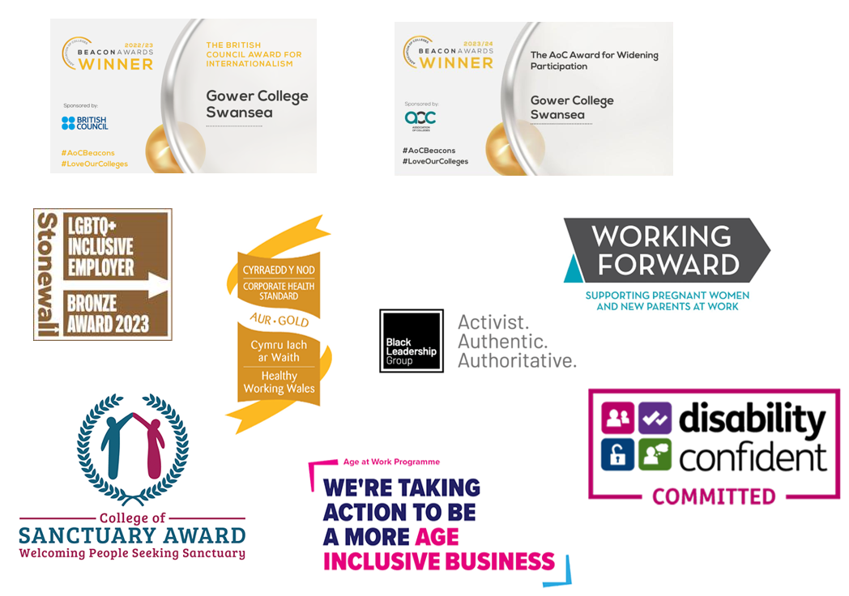Beacon Award for Widening Participation

# **Engagement and Consultation**

To develop our Strategic Equality Plan, we've considered Welsh Government Reports, including the Anti-Racist Wales Action Plan and the LGBTQ+ Action Plan for Wales. We have also examined the latest “Is Wales Fairer report 2023”, looking at the key findings under each protected characteristic and using this information to help form our objectives. These objectives have been developed through a collaborative effort within our college, where staff members contributed insights and suggestions for actions to achieve our strategic goals for each protected characteristic. Additionally, we've taken into account the following considerations:

* Current College demographics, progression reports and equality data gathered over the last 4 years.
* The local and National demographics as provided from the 2021 Census.
* The Black Leadership Group consultation and advice on creating an anti-racist organisation
* Stonewall Rainbow Britain Report 2022
* Is Wales Fair Report 2018

We have also requested feedback via an online form that was submitted directly to the following groups:

* Trade Unions
* Student Union Management Group
* Staff Equality and Diversity Committee
* Wider Staff and Student population of Gower College Swansea
* Black Leadership Group
* Stonewall Cymru
* Swansea Carers Centre
* EYST

**Terminology**

Following consultation with staff and students from our Black Asian and Minority Ethnic communities we have opted to use the term BAME (Black Asian Minority Ethnic) for reporting purposes. However, we are aware that for some, there are other terms that encompass the range of cultural identities and ethnicities that exist such as BI/POC (Black Indigenous/ People Of Colour) Global majority, individuals form ethnically diverse backgrounds. We have chosen to use BAME based on feedback from staff and students within our college community.

# **Purpose of Objectives**

The objectives and actions that follow are designed to address the concerns and inequalities that have been raised from staff and student feedback and the reports listed above. Each objective addresses a specific protected characteristic that our stakeholders have agreed should be a college priority over the next four years.

* **Age:** We will develop, support and nurture our staff and learners across all ages
* **Race:** We will improve our academic outcomes for learners from diverse cultural backgrounds, increase the number of staff from black, Asian and minority ethnicities working at the college, while promoting anti-racism and inclusion.
* **Sexual Orientation:** We will provide a safe learning and working environment for those of all different Sexual Orientations
* **Pregnancy and Maternity:** We will provide equality of opportunity for any staff or learner who are on or due to take maternity leave.
* **Marriage and civil partnership:** We will provide a safe learning and working environment for staff and learners regardless of their marital or civil partnership status
* **Sex:** We will provide a safe environment, free of sexual harassment and discrimination
* **Religion and Belief:** We will provide an inclusive and safe environment for individuals, where our staff and learners can be open and confident in their practice of religious practices and beliefs.
* **Disability:** We will ensure that learning and employment opportunities are available to all with disabilities.
* **Gender reassignment:** We will create an informed, welcoming and supportive culture that promote the rights of those who have or are transitioning.

After a thorough period of consultation, Gower College Swansea has decided not to include 'Marriage and Civil Partnership' as a protected characteristic in our strategic equality objectives. The feedback we received indicated that the actions associated with our sexual orientation objective are sufficient to meet the needs associated with this characteristic."

We aim that in the creation and development of these objectives we can overcome barriers and inequalities highlighted by our staff and learners and in doing so create a college community that is inclusive, compassionate and welcomes diversity. The college believes that in aiming to achieve these objectives both staff and learners will feel valued, supported, and empowered to achieve their full potential regardless of their background or any characteristics.

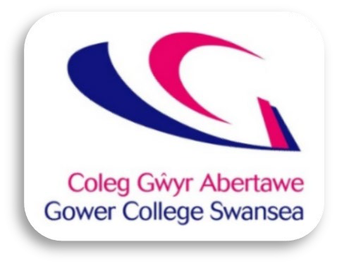

# **AGE**

We will develop and support our staff and learners across all ages

To progress this objective, we propose the following Actions:

|  |  |  |
| --- | --- | --- |
| **Action** | **Timeframe** | **Responsibility** |
| Provide upskilling and mentoring opportunities in Digital Technologies | July 2026 | Director of Skills  and Business Development |
| Develop a marketing strategy that is inclusive of all ages |  | Director of Curriculum &  Quality |
| Advertise job vacancies across multiple platforms utilising traditional and non- traditional platforms | June 2024 | Director of HR |
| Develop wellbeing support and activities that are age inclusive. | September 2025 | Director of HR |
| Develop an ageing workplace benefits survey to capture the needs of our employees across the age groups. | September 2025 | Director of HR |

# **Gender Reassignment**

We will create an informed, welcoming and supportive culture that promotes the rights of those who have or are transitioning.

To progress this objective, we propose the following Actions:

|  |  |  |
| --- | --- | --- |
| **Action** | **Timeframe** | **Responsibility** |
| Provide pronoun badges free of charge to staff and learners, encouraging members of the college to apply pronoun preferences within introduction and e-mail signatures. | June 2024 | Director of HR |
| Update Staff and Student systems to increase the range of gender characteristics available as well as multiple honorifics. | September 2024 | Executive  Management Team |
| Promote our gender-neutral facilities, policies and support options both internally and externally – ensuring they are easily accessible. | June 2024 | Executive Management Team |
| Provide training packages for all staff on trans awareness and inclusion. |  | Director of HR/ Director of Curriculum &  Quality |
| As part of our equality impact assessment process, any new policies will be reviewed to ensure gender neutral language is included throughout. |  | All Managers |

# **Sexual Orientation**

We will provide a safe learning and working environment for of all different Sexual Orientations.

To progress this objective, we propose the following Actions:

|  |  |  |
| --- | --- | --- |
| **Action** | **Timeframe** | **Responsibility** |
| Develop a training program for all staff on sexual orientation and identities |  | Director of Curriculum &  Quality |
| Continue to celebrate LGBTQ+ awareness campaigns through the academic year through our “rainbow” initiatives. | May 2024 | Executive  Management Team |
| Continuously support and promote the staff LGBTQ+ network and student LGBTQ+ officer across the college campuses. | May 2024 | Executive Management  Team |
| Actively attend local “pride” events and ensuring that Gower College Swansea has a full presence at these events. | June 2024 | Equality & Diversity Officer |

# **Pregnancy & Maternity**

We will provide equality of opportunity for any staff or learner who are on/or due to take maternity leave.

To progress this objective, we propose the following Actions:

|  |  |  |
| --- | --- | --- |
| **Action** | **Timeframe** | **Responsibility** |
| Develop a pregnancy and maternity policy for learners – outlining support on offer for our students. |  | Director of  Curriculum & Quality |
| Develop training for managers on how to support colleagues who are pregnant or on maternity/parental/adoption leave. | September 2025 | Director of HR |
| Explore discounts for staff and learners with local childcare organisations. |  | Director of HR |
| Expand our Sport centre provision of holiday clubs for children. |  | Director of  Curriculum & Quality |
| Make available the maternity/paternity pack on the staff portal. |  | Director of HR |



# **Disability**

We will ensure that learning and employment opportunities are accessible to all with disabilities.

To progress this objective, we propose the following Actions:

|  |  |  |
| --- | --- | --- |
| **Action** | **Timeframe** | **Responsibility** |
| Update our disabled parking bays to “blue badge holder only signage” alongside an awareness raising campaign. | End of May 2024 | Director of Estates |
| Ensure accessibility is considered with Estates planning and building works  *Additional to part M build regs -Project Initiation Document (PID) to include prompt Procurement to refer to College Policy in this respect* | April 2024 | Director of Estates |
| Develop a digital training suite to improve knowledge and awareness of different disabilities and chronic conditions to include upskilling staff on mental health issues, neuro-diversity and hidden disabilities. | September 2026 | Equality & Diversity Officer |
| Raise the profile and awareness of mental health initiatives such as Time to Talk. | March 2025 | Director of HR |
| Promote our disability confident status across our social media platforms and recruitment packages. | September 2024 | Director of HR |
| Review our hoist provision and ensure we have adequate and appropriate equipment for staff and learners. | June -September  2024 | Director of Estates |

# **Religion & Belief**

We will provide an inclusive and safe environment for individuals, where our staff and learners can be open and confident in their practice of religious practices and beliefs.

To progress this objective, we propose the following Actions:

|  |  |  |
| --- | --- | --- |
| **Action** | **Timeframe** | **Responsibility** |
| Provide appropriate prayer room provision across all campuses | September 2024 | Executive  Management Team |
| Provide inclusive sports kits to learners |  | Director of Curriculum &  Quality |
| Celebrate and promote a diverse range of religious faiths and festivals across the college. | May 2024 | Equality & Diversity Officer |
| Improve our catering provision for those with dietary requirements and improved descriptions and signage. |  | Director of Curriculum & Quality |
| Link in with community faith leaders to provide staff and learners with support around faith. | September 2025 | Equality & Diversity Officer |

# **Sex**

We will provide a safe environment, free of sexual harassment and discrimination.

To progress this objective, we propose the following Actions:

|  |  |  |
| --- | --- | --- |
| **Action** | **Timeframe** | **Responsibility** |
| Provide a programme of Sexual harassment training and workshops for both staff and learners |  | Director of Curriculum &  Quality |
| Develop a cross college “Call it out Campaign” encouraging staff and students to call out any inappropriate behaviour and relate back to the 9 protected characteristics, | September 2024 | Equality & Diversity Officer |
| Offer specific training for managers on how to deal with inappropriate behaviour and language, creating safe work environments and conflict resolution. |  | Director of Curriculum &  Quality |
| Become a “White Ribbon” Accredited organisation | September 2024 | Director of HR |
| Promote mixed gender sports across the college. |  | Director of  Curriculum & Quality |

# **Race**

We will improve our academic outcomes for learners from diverse cultural backgrounds, increase the number of staff from Black, Asian and Minority Ethnicities working at the college, whilst promoting diversity, cultural understanding, anti-racism and inclusion.

To progress this objective, we propose the following Actions:

|  |  |  |
| --- | --- | --- |
| **Action** | **Timeframe** | **Responsibility** |
| Provide a programme of anti-racist training for all staff which includes unconscious bias and cultural sensitivity. |  | Director of Curriculum & Quality |
| Partner with EWC BAME Recruitment Officer to promote careers and opportunities across local BAME communities | June 2026 | Director of HR |
| Work with community organisations to explore mentoring programs and cultural exchange events etc. | September 2027 | Director of HR |
| Hold focus groups with staff, learners and the local community to capture lived experiences and how the college can provide support |  | Director of Curriculum & Quality/ Director  of HR |
| Celebrate Black history month and relevant cultural events throughout the academic year. | September 2024 | Equality & Diversity Officer |

|  |  |  |
| --- | --- | --- |
| Develop an enhanced information induction pack to highlight services, facilities, policies and clubs to be made available to students on transition days, induction and open evenings. |  | Director of Curriculum & Quality |
| Monitor educational outcomes by ethnicity and subject area, using this information to highlight any potential additional support that may be required. |  | Director of Curriculum &  Quality |
| Develop and embed an inclusive and diverse curriculum that challenges stereotypes and implements the resources developed by the FE diverse curriculum working group network in Wales. |  | Director of Curriculum &  Quality |