**Equality Annual Report**

**2022-2023**

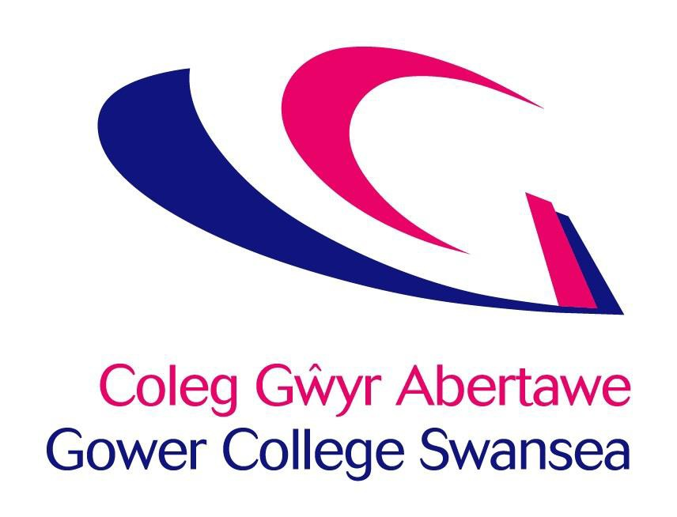

**

# Contents

**Page**

* Welcome 3
* Overview 4
* Age 5-6
* Disability 7-8
* Ethnicity 9-10
* Sex and Gender 11-12
* Religion and Belief 13-14
* Sexual Orientation 15-16
* Marriage and Civil Partnership 17-18
* Pregnancy and Maternity 19
* Student Data 20
* Celebrating Diversity 21
* Appendix 1-3 22-26
* Equality Team Contact Details 27-28

# Welcome & Introduction

**As a Public Sector organisation, Gower College is legally required to publish our equality monitoring data, however, we are fully committed to reflecting equality, diversity and inclusion throughout the institution. This report primarily ensures our compliance with the Public Sector Equality Duty, but the content of the report is also used to inform the College’s priorities for equality, diversity and inclusivity.**

I am immensely proud to work at Gower College Swansea, a College of Further Education because of our strong commitment to inclusivity. We strive to serve our diverse communities by offering individualised support that can truly make a difference to people’s lives.

You can observe this inclusivity within our student body every day and through such a diverse range of provision that we provide. For example, on any given day there will be a wide variety of learners attending our campuses, from school pupils utilising our social space alongside full-time learners striving to attend prestigious universities interacting with vocational learners mastering their chosen trades, from higher education learners studying for their higher-level qualifications to apprentices attending one day a week tuition. Furthermore, we have International learners accessing our provision, sitting alongside adults pursuing part-time courses, while leaners studying English as a second language engage with our employability clients whom we support in their job search.

While many of our learners share common threads in their stories, there are some notable differences among various groups and between individuals that truly enrich and invigorate the College environment. These distinctions not only contribute to the vibrancy of our College but also underscore our commitment to diversity and lifelong learning.

This Annual Report outlines our ongoing journey towards becoming the diverse institution that we all want and need it to be. It outlines the challenges we face and the strategies we are utilising to respond to these challenges – many of which are working and some which need further refinement. It is the story of a journey which never ends but one that we hope that, by reading this report and reflecting on it, you will want to join us on.

**Kelly Fountain**

**Principal**

# College Overview

**The College currently employs: 1,059 members of staff:**

|  |  |  |
| --- | --- | --- |
| **Gender** | **Average Age** | |
| Female | | 47 |
| Male | | 48 |
| **All** | | 47 |

|  |  |  |
| --- | --- | --- |
| **Disability** | | |
| No disability | 53.6% | 568 |
| With disability | 6.1% | 70 |
| Not answered | 39.8% | 421 |

|  |  |  |
| --- | --- | --- |
| **Ethnicity** | | |
| BAME | 4.6% | 49 |
| White | 92.1% | 975 |
| Prefer not to say | 0.9% | 10 |
| Not Answered | 2.4% | 25 |

|  |  |  |
| --- | --- | --- |
| **Gender/Sex** | | |
| Male | 38% | 402 |
| Female | 61.9% | 656 |
| Trans person | 0.1% | 1 |

|  |  |  |
| --- | --- | --- |
| **Religion and Belief** | | |
| Agnostic | 4.3% | 46 |
| Atheist | 5.8% | 61 |
| Buddhist | 0.2% | 2 |
| Christian | 29% | 307 |
| Hindu | 0.1% | 1 |
| Humanist | 0.4% | 4 |
| Muslim | 1% | 11 |
| None | 4.1% | 43 |
| Other | 6.8% | 72 |
| Prefer not to say | 7.7% | 82 |
| Declined | 40.6% | 430 |

|  |  |  |
| --- | --- | --- |
| **Sexual Orientation** | | |
| Heterosexual | 53.8% | 570 |
| Bisexual | 0.8% | 8 |
| Gay Man | 0.5% | 5 |
| Lesbian | 1% | 11 |
| Prefer not to say | 4.3% | 46 |
| Not answered | 39.6% | 419 |
| Total LGBTQ+ |  | 2.3% |

|  |  |  |
| --- | --- | --- |
| **Marriage & Civil Partnership** | | |
| Civil Partnership | 0.9% | 10 |
| Cohabitating | 12.5% | 132 |
| Divorced | 6.5% | 69 |
| Married | 53.5% | 567 |
| Separated | 1.5% | 16 |
| Single | 21.5% | 228 |
| Widowed | 0.8% | 6 |
| Not answered | 2.9% | 31 |

# Age

**Table 1.1 Staff Composition**

|  |  |  |
| --- | --- | --- |
| **Age Group** | **Staff %** | **Staff number** |
| 16-24 | 4.5% | 48 |
| 25-34 | 11.2% | 119 |
| 35-44 | 21.6% | 229 |
| 45-54 | 31% | 328 |
| 55-60 | 15.5% | 164 |
| 61-64 | 8.4% | 89 |
| 65+ | 7.7% | 82 |

|  |  |
| --- | --- |
| Gender | **Average Age** |
| Female | 47 |
| Male | 48 |
| **All** | 47 |

**Table 1.2 Average Ages**

**Table 1.3 Staff leavers by age group**

|  |  |  |
| --- | --- | --- |
| **Age Group** | **Percentage of staff leavers** | **Number of Staff leavers** |
| 16-24 | 13.5% | 24 |
| 25-34 | 24.2% | 43 |
| 35-44 | 23.6% | 42 |
| 45-55 | 16.3% | 29 |
| 55-60 | 9.6% | 17 |
| 61-65 | 7.3% | 13 |
| 65+ | 5.6% | 10 |
| Total leavers |  | 178 |

**Table 1.4 Applications by age group Received**

|  |  |  |
| --- | --- | --- |
| **Age group** | **Percentage of applications** | **Number of applicants** |
| 16-18 | 0.3% | 7 |
| 19-24 | 9.6% | 203 |
| 25-29 | 13.8% | 293 |
| 30-39 | 25.1% | 533 |
| 40-54 | 31.6% | 671 |
| 55-65 | 10.2% | 217 |
| Less Than 16 | 1.3% | 27 |
| Not Answered | 7.1% | 151 |
| Over 65 | 0.9% | 19 |

**Table 1.5 Conversion rate of application by age.**

|  |  |  |
| --- | --- | --- |
| **Age Group** | **Percentage of appointed applicants** | **Number of appointed applicants** |
| 16-18 | 42.9% | 3 |
| 19-24 | 13.8% | 28 |
| 25-29 | 7.8% | 23 |
| 30-39 | 10.9% | 58 |
| 40-54 | 9.4% | 63 |
| 55-65 | 15.2% | 33 |
| Not Answered | 5.3% | 8 |
| Over 65 | 15.8% | 3 |

# Staff Composition Age Range

* The average age of staff has remained the same at 47
* 84% of staff are over the age of 35

# Recruitment

**Number of positions recruited for: 222**

Of the Applicants who disclosed their age:

* 23% were under the age of 30
* 31% were from the 40-54 age range
* 11% were 55 plus
* The greatest conversion of applications to appointments were those under 25

## **Leavers**

* The largest number of staff leaving remain the same as previous years – those that fall within the 25-34 age range, proportionally more younger staff are leaving than older.

## **Grievance and Disciplinary**

* Across the reporting period, there were 16 disciplinary and grievance cases conducted, one involved age discrimination.

# Disability

**Table 2.1 Staff Composition**

|  |  |  |
| --- | --- | --- |
| **Disability status** | **% of staff** | **Number of Staff** |
| No disability | 53.6% | 568 |
| With disability | 6.1% | 70 |
| Not answered | 39.8% | 421 |

**Table 2.2 Staff Leavers by disability status**

|  |  |  |
| --- | --- | --- |
| **Disability status** | **Percentage of Staff** | **Number of Staff** |
| No disability | 45.2% | 77 |
| With disability | 4% | 7 |
| Not answered | 52.8% | 94 |
| **Total leavers** |  | **178** |

**Table 2.3 Applications received by Disability Status**

|  |  |  |
| --- | --- | --- |
| **Disability status** | **Percentage of Staff** | **Number of Staff** |
| No disability | 96% | 2029 |
| With Disability | 4% | 92 |

**Table 2.4 Conversion rate of application by disability status.**

|  |  |  |
| --- | --- | --- |
| **Disability status** | **Percentage of converted applicants** | **Number of converted applicants** |
| No disability | 11% | 216 |
| With Disability | 7% | 6 |

**Staff Composition**

* The number of college staff that have declared a disability has increased from last year to 6.1%, an increase of 0.3%.
* 11% of the staff disclosing a disability, have a mental/emotional health condition.
* 22% of staff disclosing a disability, have a physical disability.

# Recruitment

* 4% of applicants disclosed a disability.
* There was a higher conversion rate of applicants without a disability than without.

# Leavers

* 7 members of staff with a disability left the organisation

# Grievance and Disciplinary

* Across the reporting period there has been 16 disciplinary and grievance cases conducted, none of them involved disability discrimination.

# Ethnicity

**Table 3.1 Staff Composition**

|  |  |  |
| --- | --- | --- |
| **Ethnicity** | **Percentage of staff** | **Number of Staff** |
| BAME | 4.6% | 49 |
| White | 92.1% | 975 |
| Not Answered | 2.4% | 25 |
| Prefer not to say | 0.9% | 10 |

**Table 3.2 Leavers by Ethnicity**

|  |  |  |
| --- | --- | --- |
| **Ethnicity** | **Percentage of staff** | **Number of Staff** |
| BAME | 5% | 9 |
| White | 89% | 158 |
| Not answered | 5% | 9 |
| Unsure/Not known | 1% | 2 |
| Total Leavers |  | 178 |

**Table 3.3 Applications received by Ethnicity**

|  |  |  |
| --- | --- | --- |
| **Ethnicity** | **Percentage of Applicants** | **Number of Applicants** |
| BAME | 18% | 387 |
| White | 73% | 1551 |
| Other | 1% | 27 |
| Not Answered | 5% | 116 |
| Prefer not to say | 2% | 40 |

**Table 3.4 Conversion rate of applications by Ethnicity**

|  |  |  |
| --- | --- | --- |
| **Ethnicity** | **Percentage of converted Applicants** | **Number of converted Applicants** |
| BAME | 2.8% | 11 |
| White | 13.2% | 204 |
| Other | 3.7% | 1 |
| Not Answered | 3.4% | 4 |
| Prefer not to say | 5.0% | 2 |

**Staff Composition**

* The number of staff who identify as Black, Asian and Minority Ethnic (BAME) has increased by 0.4%.
* This represents an increase of 5 members of staff with a BAME background.
* The Swansea Bay BAME population pool of 8.2% (Census 2021).

**Recruitment**

* 18% of our applicants who disclosed their ethnicity are from a BAME background, 10% of those that applied attended interviews from shortlisting.
* Many of the applications were received from overseas and did not have the right to remain.
* 11 applicants from a BAME background were appointed.

**Leavers**

* 6% of those that left were from a BAME background.

**Grievance and Disciplinary**

* Across the reporting period there has been 16 disciplinary and grievance cases conducted, one of them involved racial and ethnic discrimination.

# Sex and Gender

**Table 4.1 Staff Composition**

|  |  |  |
| --- | --- | --- |
| **Gender** | **Percentage of staff** | **Number of Staff** |
| Male | 38% | 402 |
| Female | 61.9% | 656 |
| Trans person | 0.1% | 1 |
| All |  | 1059 |

**Table 4.2 Leavers by Gender**

|  |  |  |
| --- | --- | --- |
| **Gender** | **Percentage of staff** | **Number of Staff** |
| Male | 41% | 73 |
| Female | 59% | 105 |
| Total leavers |  | 178 |

**Table 4.3 Applications received by gender**

|  |  |  |
| --- | --- | --- |
| **Gender** | **Percentage of Applicants** | **Number of Applicants** |
| Male | 36.1% | 765 |
| Female | 57.6% | 1222 |
| Trans | 0.1% | 2 |
| Not Answered | 5.1% | 109 |
| Prefer not to say | 1.1% | 23 |

**Table 4.4 Conversion rate of applications by gender**

|  |  |  |
| --- | --- | --- |
| **Gender** | **Percentage of converted Applicants** | **Number of converted Applicants** |
| Male | 10.5% | 80 |
| Female | 11.1% | 136 |
| Not Answered | 3.7% | 4 |
| Prefer not to say | 8.7% | 2 |

**Table 4.5 Median and Mean Gender Pay Gap**

|  |  |
| --- | --- |
| **Average** | **Percentage** |
| Mean | 7.65% |
| Median | 12.8% |

|  |  |  |  |  |
| --- | --- | --- | --- | --- |
| Gender | Contract | | Contract | |
|  | Full Time | | Part Time/Term Time | |
| Male | 24% | 255 | 14% | 147 |
| Female | 26% | 271 | 36% | 385 |
| Trans person | - | - | 0.1% | 1 |
| All | 48% | 526 | 51% | 533 |

**Table 4.6 Breakdown of Staff by Gender and Contract Type**

|  |  |  |  |  |
| --- | --- | --- | --- | --- |
| Gender | Permanent | | Temporary | |
| Male | 29% | 306 | 9% | 96 |
| Female | 44% | 466 | 18% | 190 |
| Trans person | 0.1% | 1 | - | - |
| All | 73% | 773 | 27% | 286 |

**Table 4.7 Breakdown of Staff by Gender and Contract Status**

## **Staff Composition**

* Gender split of staff has remained consistent, there remains only one employee who has disclosed their trans status.
* 59% of all lecturing staff are female in line with the general workforce split.
* 58% of the management team of the college are female, which is reflective of the workforce split.
* 63% of Business Support staff are female.

## **Recruitment**

* 57.6% of applications received were from female applicants in contrast to male applicants at 36.1%
* The success rate for women is slightly higher than for men (11.1% and 10.5% respectively).
* 2 applications were received from individuals who identify as neither male or female.

## **Leavers**

* The percentage of leavers split across the genders are 41% male and 59% female which is comparable to our workforce split.

## **Grievance and Disciplinary**

* Across the reporting period there has been 16 disciplinary and grievance cases conducted, one of these cases involved sexual harassment.

## **Contract Type**

* There is a higher percentage of women on permanent contracts (44%) compared to men (29%).
* The number of men on part time contracts has increased to 14% but remains less than half the number of their female counterparts.

## **Gender Pay Gap \***

* The mean pay gap is at 7.65% and the median is 12.8 % which has widened on both accounts from previous years.
* This is being driven by an increase in the amount of females hired in the lowest earning quartile and a reduction of males in this quartile.

# Religious Belief

**Table 5.1 Staff Composition**

|  |  |  |
| --- | --- | --- |
| **Religious Belief** | **Percentage of staff** | **Number of Staff** |
| Agnostic | 4.3% | 46 |
| Atheist | 5.8% | 61 |
| Buddhist | 0.2% | 2 |
| Christian | 29% | 307 |
| Hindu | 0.1 | 1 |
| Humanist | 0.4% | 4 |
| Muslim | 1% | 11 |
| None | 4.1% | 43 |
| Other | 6.8% | 72 |
| Declined | 48.3% | 512 |
| Total |  | 1059 |

**Table 5.2 Leavers by Religious belief**

|  |  |  |
| --- | --- | --- |
| **Leavers by Religion** | **Percentage of staff** | **Number of Staff** |
| Agnostic | 6% | 10 |
| Atheist | 4% | 8 |
| Christian | 19% | 33 |
| Declined | 7% | 13 |
| None | 3% | 5 |
| Other | 7% | 12 |
| Not answered | 54% | 97 |
| Total |  | 178 |

**Table 5.3 Applications received by Religious Belief**

|  |  |  |
| --- | --- | --- |
| **Religious Belief** | **Percentage of Applicants** | **Number of Applicants** |
| Buddhist | 1.4% | 29 |
| Christian | 33.9% | 720 |
| Hindu | 2.5% | 53 |
| Jewish | 0.3% | 6 |
| Muslim | 6.0% | 127 |
| None | 41.9% | 888 |
| Other | 1% | 42 |
| Not answered | 5.3% | 112 |
| Prefer not to say | 6.5% | 138 |
| Sikh | 0.3% | 6 |
| Total |  | 2121 |

**Table 5.4 Conversion rate of applications by religious belief**

|  |  |  |
| --- | --- | --- |
| **Religious Belief** | **Percentage of converted Applicants** | **Number of converted Applicants** |
| Buddhist | 6.9% | 2 |
| Christian | 11.1% | 80 |
| Hindu | 3.8% | 2 |
| Muslim | 2.4% | 3 |
| None | 13.2% | 117 |
| Other | 3.6% | 1 |
| Not answered | 2.4% | 4 |
| Prefer not to say | 9.4% | 13 |
| Total |  | 222 |

## **Staff Composition**

* A wide range of beliefs and non-beliefs are represented within our staff profile.
* Over 48% of individuals working at the college prefer not to disclose their religion and belief, which relates to 1% reduction from last year.
* Our largest cohort of staff remains from those that identify as Christian.

Table 5.5 Faith Groups in Swansea demographics

|  |  |
| --- | --- |
| **Religious Belief** | **Swansea Population %** |
| No Belief | 47.3% |
| Christian | 41.3% |
| Buddhist | 0.4% |
| Hindu | 0.4% |
| Jewish | 0.1% |
| Muslim | 3.2% |
| Sikh | 0.1% |
| Other Religion | 0.5% |
| Not answered | 6.7% |

***\*Census 2021***

## **Recruitment**

* The largest proportion of applications received were from those who identify as having no religion (42%), followed by Christian (33%).
* 12% of applicants chose not to disclose this information.
* The highest percentage of those appointed, were those with no belief at 13%, followed by those who were Christian at 12%.
* The number of people applying from a Muslim faith has increased by 33% increasing from 95 applicants to 127

## **Grievance and Disciplinary**

* Across the reporting period there has been 16 disciplinary and grievance cases conducted, one of these cases involved religious belief discrimination.

# Sexual Orientation

**Table 6.1 Staff Composition**

|  |  |  |
| --- | --- | --- |
| **Sexual Orientation** | **Percentage of staff** | **Number of Staff** |
| Heterosexual | 53.8% | 570 |
| Bisexual | 0.7% | 8 |
| Gay Man | 0.5% | 5 |
| Lesbian | 1% | 11 |
| Prefer not to say | 4.3% | 46 |
| Not answered | 39.6% | 419 |
| Total LGBTQ+ |  | 2.3% |

**Table 6.2 Leavers by Sexual Orientation**

|  |  |  |
| --- | --- | --- |
| **Sexual Orientation** | **Percentage of staff** | **Number of Staff** |
| Heterosexual | 40% | 71 |
| Bisexual | 3% | 5 |
| Lesbian | 1% | 1 |
| Prefer not to say | 3% | 7 |
| Not answered | 54% | 94 |
| Total Leavers |  | 178 |

**Table 6.3 Applications received by Sexual Orientation**

|  |  |  |
| --- | --- | --- |
| **Sexual Orientation** | **Percentage of Applicants** | **Number of Applicants** |
| Bisexual | 4.1% | 87 |
| Gay Man | 1.5% | 31 |
| Lesbian | 0.9% | 19 |
| Heterosexual | 82.2% | 1743 |
| Not Answered | 5.5% | 116 |
| Prefer not to say | 5.9% | 125 |
| Total LGBTQ+ | 6.5% | 137 |

**Table 6.4 Conversion rate of applicants by Sexual Orientation**

|  |  |  |
| --- | --- | --- |
| **Sexual Orientation** | **Percentage of converted Applicants** | **Number of converted Applicants** |
| Bisexual | 8.0% | 7 |
| Gay Man | 9.7% | 3 |
| Gay Woman/ Lesbian | 5.3% | 1 |
| Heterosexual | 11.5% | 200 |
| Not Answered | 3.4% | 4 |
| Prefer not to say | 5.6% | 7 |
| Total LGBTQ+ | 8.0% | 11 |

# Staff Composition

* 2.3% of our staff cohort identify as LGBTQ+ which is slightly under the current LGBTQ+ demographic of Swansea of 3.3% (Census 2021).
* 44% of our staff choose not to disclose this information, which remains the same level as last year.

# Recruitment

* 6.5% of all applications were from the LGBTQ+ community compared to 4.4% last year.
* We have appointed 11 applicants who identify as LGBTQ+ this year in comparison to 10 last year.

# Leavers

* 4% of staff members that left the college identify as LGBTQ+.

# Grievance and Disciplinary

* Across the reporting period there has been 16 disciplinary and grievance cases conducted, none involved sexual orientation discrimination.

# Marriage and Civil Partnership

**Table 7.1 Staff Composition**

|  |  |  |
| --- | --- | --- |
| **Marital Status** | **Percentage of staff** | **Number of Staff** |
| Civil Partnership | 0.9% | 10 |
| Cohabitating | 12.5% | 132 |
| Divorced | 6.5% | 69 |
| Married | 53.5% | 567 |
| Separated | 1.5% | 16 |
| Single | 21.5% | 228 |
| Widowed | 0.8% | 6 |
| Not answered | 2.9% | 31 |

**Table 7.2 Leavers by Marital status**

|  |  |  |
| --- | --- | --- |
| **Marital Status** | **Percentage of staff** | **Number of Staff** |
| Civil Partnership | 1% | 1 |
| Co-habiting | 12% | 22 |
| Divorced | 3% | 6 |
| Married | 43% | 76 |
| Separated | 2% | 3 |
| Single | 37% | 66 |
| Widowed | 1% | 2 |
| Not answered | 1% | 2 |
| Total |  | 178 |

**Table 7.3 Applications received by Marital Status**

|  |  |  |
| --- | --- | --- |
| **Marital Status** | **Percentage of applicants** | **Number of applicants** |
| Civil Partnership | 1.1% | 24 |
| Cohabitating | 10.6% | 224 |
| Divorced | 4.3% | 91 |
| Married | 37.4% | 794 |
| Separated | 2.5% | 53 |
| Single | 25.6% | 543 |
| Widowed | 0.5% | 10 |
| Not answered | 16.1% | 341 |
| Other | 0.8% | 17 |
| Prefer not to say | 1.1% | 24 |

**Table 7.4 Conversion rate of applicants by Marital Status**

|  |  |  |
| --- | --- | --- |
| **Conversion rate of applicant by Marriage & Civil Partnership** | **Percentage of converted Applicants** | **Number of Converted Applicants** |
| Civil Partnership | 1% | 3 |
| Cohabitating | 13% | 29 |
| Divorced | 11% | 10 |
| Married | 12% | 96 |
| Separated | 15% | 8 |
| Single | 12% | 66 |
| Widowed | 10% | 1 |
| Not answered | 2% | 7 |
| Other | 6% | 1 |
| Prefer not to say | 4% | 1 |

**Staff Composition**

* The vast majority of our staff are married (54%) followed by single (22%).
* 10 staff have declared that they are in a civil partnership.

**Grievance and Disciplinary**

* Across the reporting period there has been 16 disciplinary and grievance cases conducted, none involved marriage or civil partnership discrimination.

# Pregnancy and Maternity

**23 Members of staff took Maternity or Shared Parental Leave**

## **Grievance and Disciplinary**

* Across the reporting period there has been 16 disciplinary and grievance cases conducted, none involved Maternity or Pregnancy discrimination.

# Student Data Overview

**Table 9.1 Student numbers**

|  |  |  |
| --- | --- | --- |
| **Student status** | **Student Percentage** | **Student numbers** |
| Full Time | 33.5% | 4756 |
| Part Time | 66.5% | 9461 |
| Total |  | 14217 |

**Table 9.2 Student Gender Breakdown**

|  |  |  |
| --- | --- | --- |
| **Gender** | **Student Percentage** | **Student numbers** |
| Male | 48.6% | 6912 |
| Female | 50.7% | 7209 |
| Other | 0.7% | 96 |
| Total |  | 14217 |

**Table 9.3 Student Disability Status**

|  |  |  |
| --- | --- | --- |
| **Disability** | **Student Percentage** | **Student numbers** |
| Disabled | 12.8% | 1825 |
| No known disability | 86.6% | 12306 |
| Unknown | 0.6% | 86 |
| Total |  | 14217 |

**Table 9.4 Student Age Data**

|  |  |  |
| --- | --- | --- |
| **Age** | **Student Percentage** | **Student numbers** |
| Under 16 | 1.8% | 215 |
| 16-19 | 32.5% | 4513 |
| 20-29 | 21.9% | 2961 |
| 30-29 | 18.6% | 2595 |
| 40-49 | 13.4% | 2078 |
| 50-59 | 8.8% | 1363 |
| 60-69 | 2.5% | 417 |
| 70-79 | 0.4% | 66 |
| 80+ | 0.1% | 9 |
| Total |  | 14217 |

**Table 9.5 Student Ethnicity**

|  |  |  |
| --- | --- | --- |
| **Ethnicity** | **Student Percentage** | **Student numbers** |
| Any Other White background | 4.1% | 578 |
| Arab | 1.2% | 173 |
| Asian – Bangladeshi | 1.0% | 144 |
| Asian – Indian | 0.5% | 65 |
| Asian – Pakistani | 0.4% | 63 |
| Black – African | 1.7% | 241 |
| Black – Caribbean | 0.1% | 20 |
| Chinese | 0.7% | 93 |
| Gypsy or Irish Traveller | 0.1% | 8 |
| Information Refused | 0.9% | 127 |
| Mixed – White and Asian | 0.7% | 100 |
| Mixed - White and Black African | 0.3% | 38 |
| Mixed – White and Black Caribbean | 0.2% | 35 |
| Not Known | 1.1% | 151 |
| Other Asian Background | 0.3% | 39 |
| Other Black Background | 0.1% | 15 |
| Other Ethnic Background | 3.0% | 425 |
| Other Mixed Background | 0.4% | 62 |
| Welsh/English/Scottish/Northern Irish/British | 83.3% | 11840 |

# Celebrating Diversity

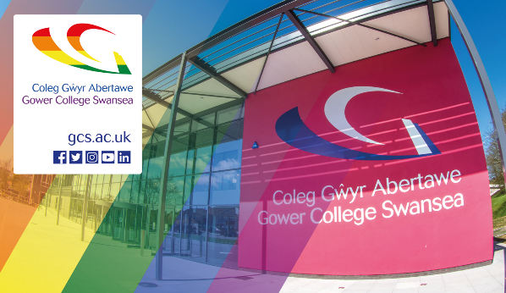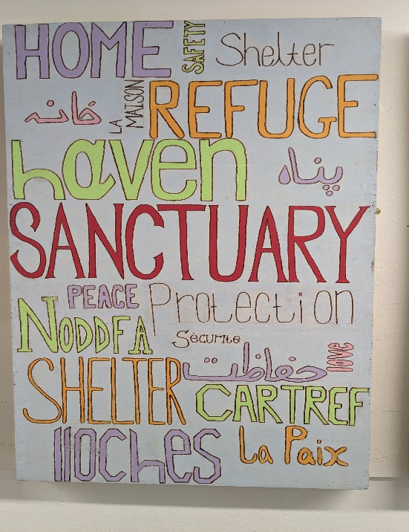

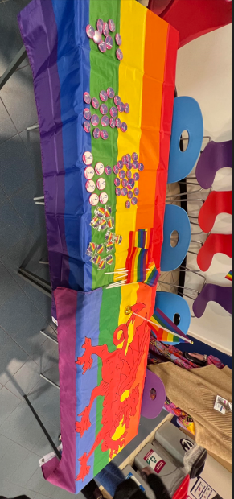

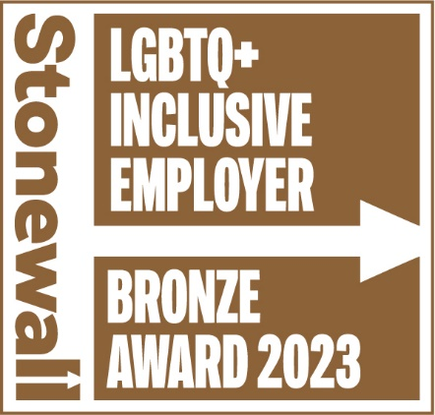

* Stone Workplace Equality Index Bronze Award Winners
* We have continued to promote equality and diversity throughout the year – holding our annual LGBTQ+ events, celebrating key dates throughout the year and continuing to deliver support to our asylum and sanctuary learners.
* Host for Roundtable Menopause champions event
* British Council Award winners for “Internationalism”
* Retained Gold Award for Corporate Health Standard with Healthy Working Wales
* Increased diversity of Student Management Group (SUMG) representation Equality groups

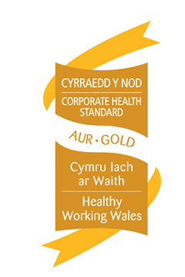

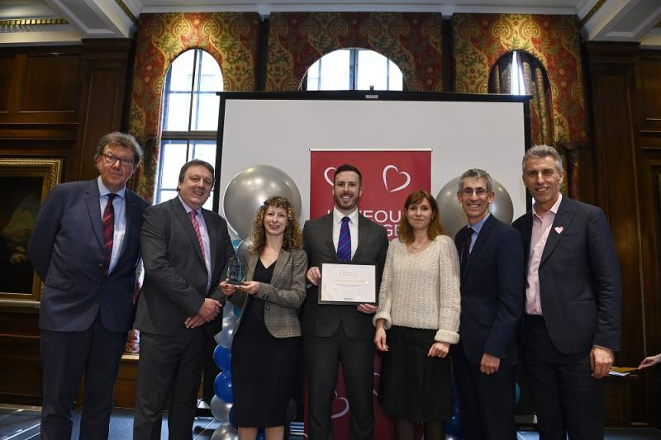

# Appendix 1: Equality Training Data/Atodiad 1: Data Hyfforddiant Cydraddoldeb

Please follow the link for access to our full breakdown of our equality training data.

[Equality Training Data](https://studentportal.gcs.ac.uk/wp-content/uploads/2024/02/Staff-Development-ED-Stats-2022-23-results.xlsx)

# Appendix 2: Strategic Equality Objectives/Atodiad 2: Amcanion Cydraddoldeb Strategol

Please follow the link for access to our full Breakdown of Progress against the our [Strategic Equality Objectives](https://studentportal.gcs.ac.uk/wp-content/uploads/2023/03/Progress-against-Objectives.docx)

Please follow the link for access to: [**Gower College Strategic Equality Plan 2022-24**](https://www.gcs.ac.uk/sites/default/files/Gower%20College%20Strategic%20Equality%20Plan%202020-2024%20-%20Final.pdf)

**Appendix 3: Staff Pay Scales /Atodiad 3: Graddfeydd Cyflog Staff**

**3.1 – Comparison of Male and Female staff in Business Support Posts**

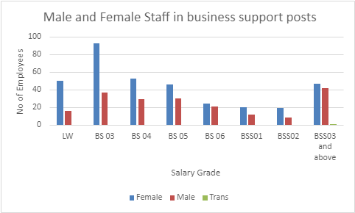

**3.2 – Comparison of total business support staff by gender.**

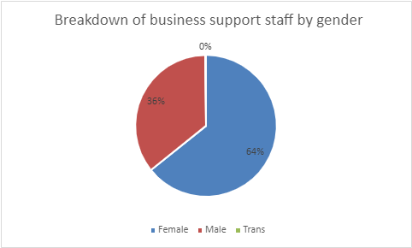

**3.3 Comparison of Male and Female staff on Lecturer scales**

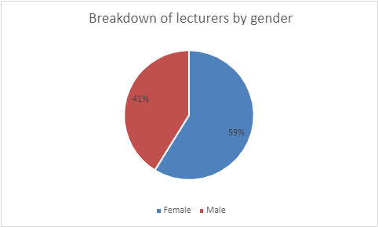

**3.3 – Comparison of Male and Female staff on Management scales**

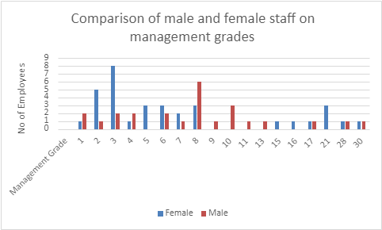

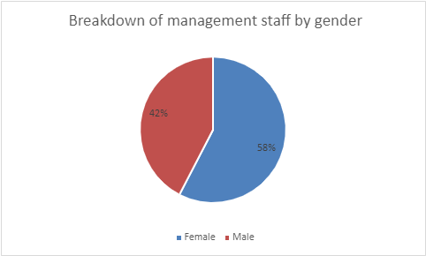

**3.4 – Comparison of Male and Female staff in Service Roles**

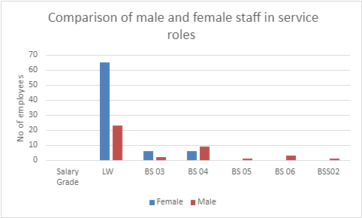

**\*\* Catering Assistants**

**Cleaners**

**Estates**

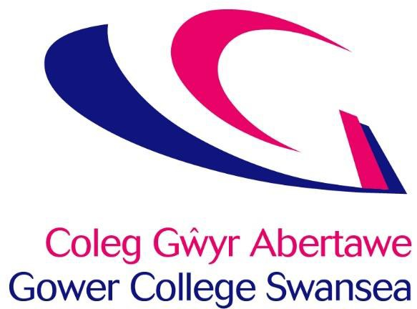

**Equality Matters**

**Mae Cydraddoldeb yn Bwysig**