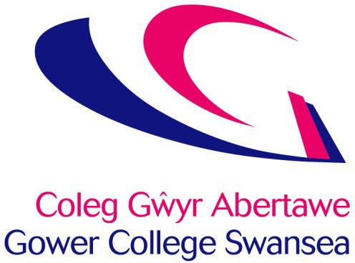

Student Appeals Procedure

Issue Date April 2024

Review Date April 2026

Originator Nikki Neale, Vice Principal Curriculum, Quality, Teaching and Learning

Location BIZ-SharePoint/Intranet/Policies & Procedures/Learner Services & Support

Approved by Senior Leadership Team – 16 May 2024

Version 3.0

Category Public

Rationale

  - The following appeals procedure has been formulated to ensure that learners in the College are treated fairly.

  - Learners have the right to appeal if they consider:

    - a complaint has not been satisfactorily resolved through the College Complaints Procedure;
    - a complaint of harassment has not been satisfactorily resolved through the College Anti-bullying Policy;
    - the College has not followed its Student Disciplinary Policy, Fitness to Study Policy, or Student Attendance Procedures;
    - an assessment decision has not been resolved satisfactorily under the College Assessment Procedure
    - they have been treated unfairly under the College Admissions Policy.

  - In the case of appeal against an assessment decision, the learner may appeal through the Awarding Body’s appeals procedure. HE learners can only appeal if they think the assessment process has not been followed, they cannot appeal an assessment decision/grade. (see Assessment, Appeals and Malpractice Policy).

Procedure

  - The learner must lodge their appeal in writing to the Principal within 5 working days of the notification from the attendance, complaints, harassment or disciplinary panel.

  - In the case of Student Misconduct (not gross misconduct) and Admissions issues only the learner must lodge their appeal in writing to the Vice Principal Curriculum, Quality, Teaching and Learning within 5 working days of notification of their exclusion from the College. The Vice Principal Curriculum, Quality, Teaching and Learning will evaluate the grounds for appeal and if there are no clear grounds for the appeal and the College has followed its procedures correctly an Appeals Panel will not be called. You will be notified of the outcome in writing within 10 working days of the date of the appeal

  - For appeals lodged with the Principal the Appeals Panel will meet within 10 working term time days of the appeal being received by the College.

  - The Appeals Panel will consist of 2 people drawn from the College’s Senior Leadership Team and/or the College Governing Body. The members of the panel will not be connected with the case in any way.

  - The learner may present his/her case to the Appeals Panel and may bring witnesses to support his/her case and may be accompanied by a parent, guardian or friend.

  - Any new evidence to be brought by the learner must be submitted to the college 5 working days before the appeal is heard.

  - If you cannot attend the hearing because of circumstances beyond your control you should advise the college as soon as possible. The College will make all reasonable efforts to reschedule any hearing. However, if you do not inform the College that you cannot attend the Appeals Panel will go ahead in your absence.

Right to be Accompanied

  - You have the right to bring a friend, guardian or parent to the appeal. The choice of companion is a matter for you and you must notify the college of your choice prior to the appeal hearing. In the case of vulnerable students, it is advised that a companion accompany you. If this is not possible the College will provide an advocate to support you during the meeting.

If the college believes that your choice of companion is unreasonable, the college will ask you to choose someone else. For example, if in the college’s opinion your companion:

- may have a conflict of interest or prejudice the meeting;

- is unavailable at the time of the meeting, if the original meeting date has already been re-arranged once due to the companion’s non availability.

- The person who accompanies the complainant should not be a solicitor acting in a professional capacity.

  - At an appeal hearing, your companion may address the panel and respond on your behalf to any views expressed. However, the hearing is essentially a hearing between you and the college and any questions put directly to you should be answered by you and not your companion, unless you request your companion to reply on your behalf.

Outcome

  - The outcome of the appeal may be:

- To confirm the decision of the attendance, admissions, complaints, harassment or disciplinary panel or to confirm the assessment decision.

- To modify or overturn the decision of the attendance, admissions, complaints, harassment or disciplinary panel or to modify or overturn the assessment decision.

Judgement

The judgment of the appeals panel is final and there is no further right of appeal. This will be issued in writing to the learner within 3 working term time days of the hearing.

The Welsh Language

  - Mae Coleg Gŵyr Abertawe yn ymrwymedig i hyrwyddo’r iaith Gymraeg, yn unol â Safonau’r Iaith Gymraeg a Mesur y Gymraeg (Cymru) 2011.

  - Gower College Swansea is committed to the promotion of the Welsh language, in accordance with the Welsh Language Standards and the Welsh Language (Wales) Measure 2011.

  - Appeals are welcome in Welsh and doing so will not delay the response.

  - If you are a Welsh speaker and wish to have your appeal meeting held through the medium of Welsh please let us know in your letter of appeal.

This procedure is also available in Welsh.

