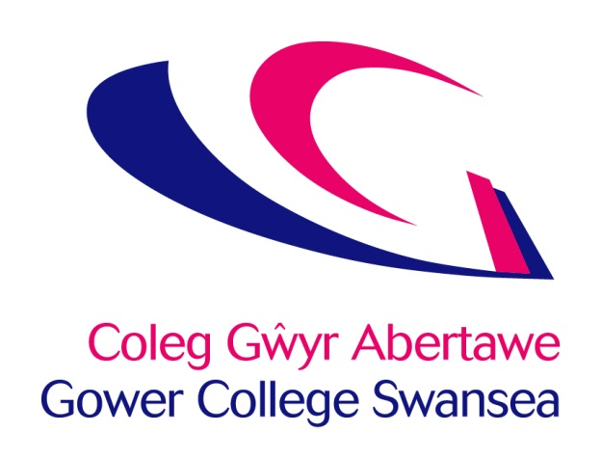

Refunds Policy

Issue July 2024

Review Date July 2027

Originator Mike Glover

Vice Principal Finance & MIS

Location of Policy BIZ-Sharepoint/Intranet/Policies & Procedures/Finance

Approved by Senior Leadership Team 20.06.24

Version 4.00

Category Public

Gower College Swansea is committed to actively promoting access, entry and participation on its courses by all members of the community.

Where the number of students attending a class falls to a level at which the class is no longer viable, the College retains the right to merge the class with another group or close the class if necessary.

In determining our refunds policy for students withdrawing from courses, the College has a duty to take account of course viability and our commitment to those students who reasonably expect their courses to continue for the full duration.

A full refund of a course fee will be given on request only if:

1. A course is cancelled by the College.
2. The course day, time or mode of delivery or venue is changed by the College.

# Refunds will not normally be given in any other circumstances

The decision to refund fees will be at the College’s discretion.

Any refunds due on HE courses will be made in accordance with the relevant HEI franchising partner’s policy.

Gower College Swansea reserves the right to charge an administration fee for refunds. The College will offset any costs, eg resources, examination costs, it may have incurred against any refund of fees due.

Any refund request will be considered and responded to within 4 weeks of receipt.

**The Welsh Language**

Mae Coleg Gŵyr Abertawe yn ymrwymedig i hyrwyddo’r iaith Gymraeg, yn unol â Safonau’r Iaith Gymraeg a Mesur y Gymraeg (Cymru) 2011.

Gower College Swansea is committed to the promotion of the Welsh language, in accordance with the Welsh Language Standards and the Welsh Language (Wales) Measure 2011.