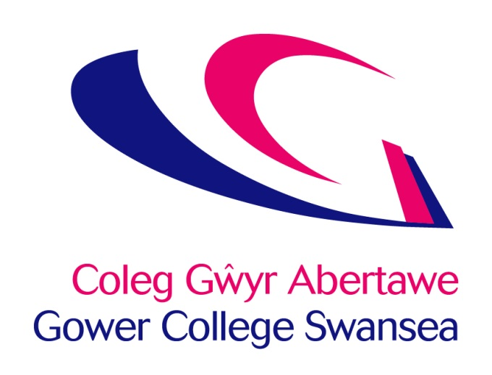

Work Based Learning Sub-Contracting Fees and Charges Policy

Issue: October 2023

Review Date: July 2024

Originator: Director of Work Based Learning

Location of Policy: BIZ-Sharepoint/Intranet/Policies &
Procedures/Finance

WBL/Admin/WBL Procedures/ESFA Procedures

WBL/Admin/WBL Procedures/WG Procedures

Approved By: College Management Team – 09.11.23

Version: 6.0

Category: Public

1. Scope

This policy applies to all supply chain activity supported with funds supplied by Welsh Government (WG) for provision funded in Wales and Education and Skills Funding Agency (ESFA) for provision funded in England, or any successor organisations.

2. Context

The Policy is a mandatory requirement that must be in place prior to participating in any subcontracting activity from 1 August 2017. Each contract year, we need to publish our sub-contracting fees and what sub-contractors receive for these fees on our website.

3. Rationale for Sub-Contracting

The College engages with sub-contractors in order to better meet customer needs and to do the following:

• To work with providers who effectively reach priority learners in the community and who can demonstrate positive learning and employment outcomes
• To provide access to, or engagement with, a new range of customers
• To support another provider to develop capacity/ quality
• To provide additional delivery where the cost of developing direct delivery would be unsustainable
- To work with providers that offer sector specific priorities supporting local, regional and national skills agendas.

All sub-contractors will be subject to the College due diligence process. Successful sub-contractors become part of the College’s Work Based Learning Delivery Team and are referred to by the College as External Delivery Partners.

4. Quality Assurance and Support Provided to Sub-Contractors

The quality of sub-contract provision is carefully monitored and managed through existing college quality assurance processes and procedures. Sub-contractors are included in the College’s WBL Quality meetings along with all delivery partners and are subject to regular contract review meetings. The College provides training for sub-contractor staff including but not limited to:

- The contract and funding body requirements
- Professional training and development for partner staff
- Use of e-portfolio and e-management information systems
- Access to learning resources and materials including access to College library and wellbeing support services
- Participation in the College’s observation of teaching, learning and assessment process
- Participation in the College self-assessment process and College annual WBL conferences and apprenticeship award ceremonies
- Access to a range of in-house training delivered by the College eg SAR training and Smart Assessor training
- Monitoring of initial guidance, assessment, delivery of learning programs and associated targets.

College staff will meet sub-contractors regularly and will provide curriculum planning advice and funding updates. Quality audits will be completed and feedback provided with priority being given to new providers or providers where there has been an identified concern regarding their performance. Support sessions on areas such as equality and diversity, data recording, safeguarding, functional/essential skills, legislative compliance and the Inspection Frameworks of both Estyn and Ofsted will be provided on request or as a group activity.

Support is provided to sub-contractors through close monitoring and tracking of learner progress using College systems and the continual review of contract performance. In addition, the College supports the sub-contractor in meeting the requirements of the Equality Act, minimising complaints and drop-out rates through a series of direct contacts with both the learners and employers via learner validation calls, employer and learner surveys. The results of this activity are shared openly and monitored to support improvement.

5. Percentage Range of Charges

The College retains a management fee which covers a proportion of the direct costs associated with operating and quality assuring sub-contract provision and which provides a contribution towards indirect costs such as finance, student support, IT and other curriculum support costs.

The typical percentage fee range retained by the College is between 15% - 20%. The fee rate takes into account the level of capacity and skills of the contractor, and the risk assessed through the due diligence process.

If the sub-contractor is a subsidiary of Gower College Swansea, service charges will be applied through the College standard annual budgeting process. This reflects the subsidiary as being an internal business unit of the College and as such, services such as governance, quality and compliance are charged centrally.

6. Payment Terms

The College will make payment to the sub-contractor within 30 days of receiving a valid claim for payment or invoice. Payments will usually follow the submission of the Individualised Learner Record (ILR) and receipt of the Occupancy Report (Provider Funding Report) by the College.

No payment will be made in respect of any learner remaining on programme where there has been no evidence of learning received for a period of 12 weeks.

7. Communication of the Supply Chain Charges Policy

This policy is published on the College internet at https://www.gcs.ac.uk/policies-and-procedures and can be sent to all sub-contractors on request.

The Policy is discussed with potential subcontractors during the due diligence and contracting process. For English work based learning delivery, the College will submit regular sub-contractor declaration returns to ESFA and publish details of the subcontractor arrangements including:

- Name of sub-contractor
- UKPRN
- Contract start date and end date
- Provision type
- Funding
- Total College income
- Total paid to sub-contractor
- Total retained in the management fee.

Welsh Government does not require the College to submit sub-contractor returns in the same manner as ESFA. However, we will still retain original signed sub-contracts and due diligence records for each sub-contractor used for Welsh work-based learning delivery.

8. Policy review

This Policy is updated annually in line with updates from the ESFA & WG funding guidance and will be reviewed in July 2024.

This Policy is ratified by the College’s Corporation Board (Governing Body).

9. Yr Iaith Cymraeg / The Welsh Language

Mae Coleg Gŵyr Abertawe yn ymrwymedig i hyrwyddo’r iaith Gymraeg, yn unol â Safonau’r Iaith Gymraeg a Mesur y Gymraeg (Cymru) 2011.

Gower College Swansea is committed to the promotion of the Welsh language, in accordance with the Welsh Language Standards and the Welsh Language (Wales) Measure 2011.

This policy is also available in Welsh

